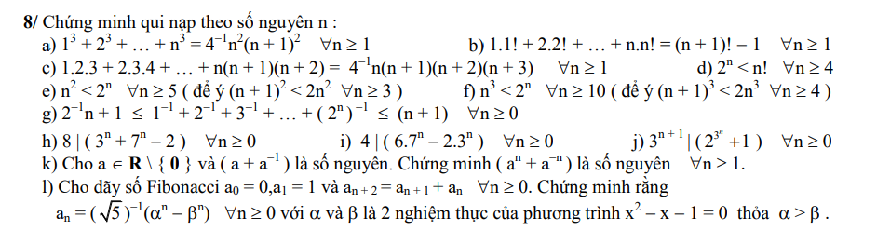

1. 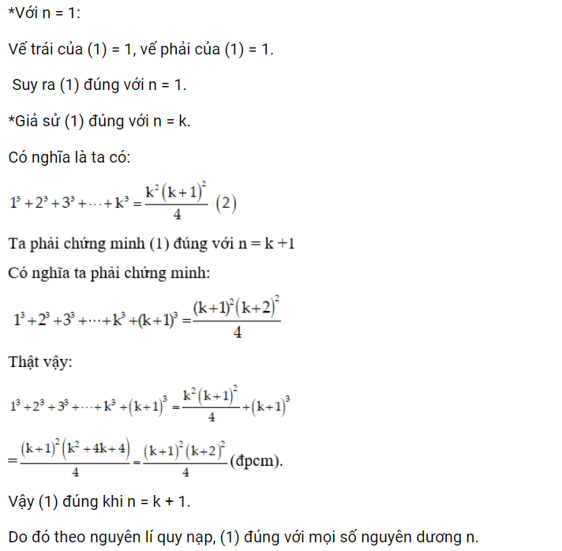
2. A screenshot of a math problem

   Description automatically generated

k) 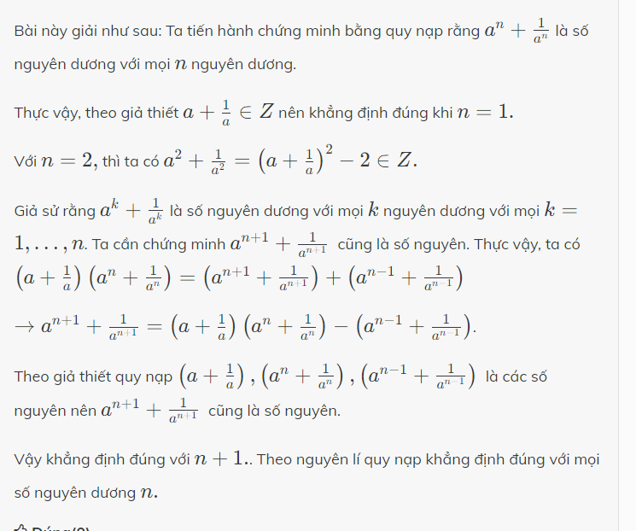



Quy nạp

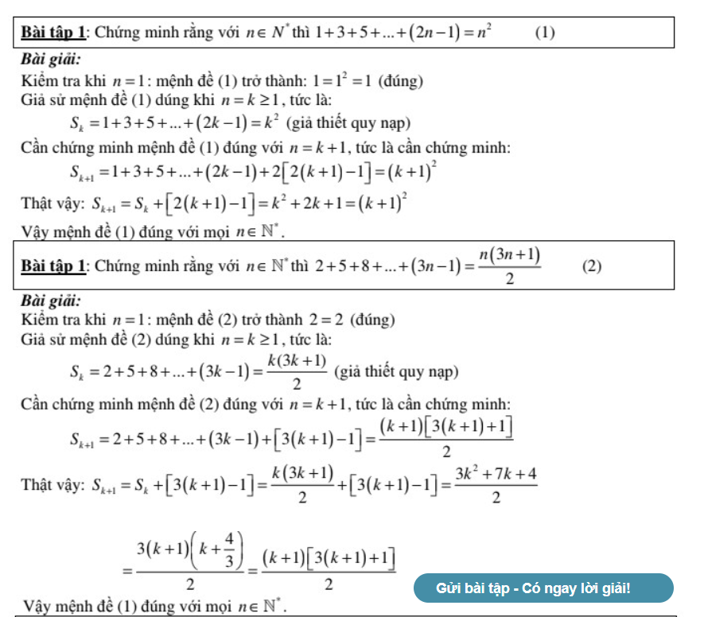

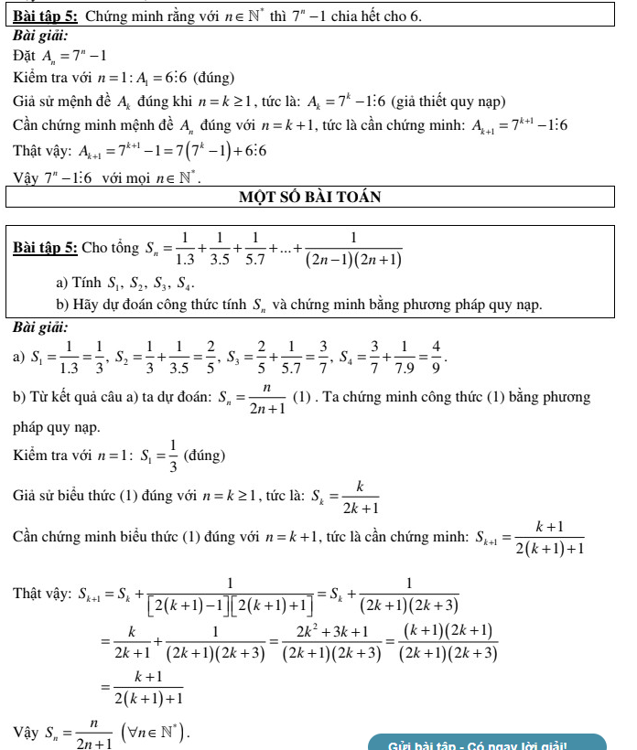

Nhị thức newton



